Phase 1 - Planning Phase

ISM 4133 ADVANCED SYSTEMS ANALYSIS AND DESIGN - GROUP PROJECT

**Content Table**

**PHASE I**

Project Planning…………………………………………………………………………………3

Letter of Consent………………………………………………………………………..3

Organization Description……………………………………………………………….5

Organizational Chart……………………………………………………………………5

System Request………………………………………………………………………...5

Preliminary Project Plan………………………………………………………………………..6

Project Time Frame……………………………………………………………………..6

Work Breakdown Structure…………………………………………………………….7

Gantt Chart……………………………………………………………………………..10

Staff Project………………….…………………………………………………….,…..11

Project Charter…………………………………………………………………………12

Control and direct project……………………………………………………………..13

Preliminary fact-finding……………………………………………………………..…14

**Phase II**

Requirements Gathering

Identify Key Stakeholders…………....……………………………………………….17

Interview Owners………………………………………………………………………18

Detailed Observation of Existing Work Process…………………………………....20

Feasibility Analysis…………………………………………………………………….21

Data Flow Diagrams………………………………………………..……………………………….23

Use Case Description………………………………………………………………..………...…...25

Functional Decomposition Diagram……………………………………………………………….28

Entity Relationship Diagram………………………………………………………………………..28

Gantt Chart………………………………………………………………………………………..….29

**Phase III**

System Design

System Acquisition Strategy……………………………………………………….…31

Designing the environment…………………………………………………………...32

Designing the application architecture………………………………………………32

Designing the user interface………………………………………………………….35

Software/Program Design…………………………………………………………….40

Designing the database controls and security………………………………….…..61

**Project Planning**

**A-** Letter of Consent

Letter of Consent

Date: _3-1- 2018____________________

This letter serves to confirm that I have given approval for the Florida Atlantic University, Advanced Systems Analysis & Design Team Members to have access to information about ***David Hunter Homes*** for the sole purpose of completing the Systems Analysis Project. The team will be working on implementing a framework that will improve end-to-end automation between the two systems (CRM System & Lead Generation System).

Group Members

***Tareq Kadamani***

***Anthony Wilson***

***Jean Viaud***

***Nguyen Tran***

______David Hunter________________________ (Signature)

***David Hunter Homes Owner***

***No address, (954) 647-3595, Davidhunter562@gmail.com***

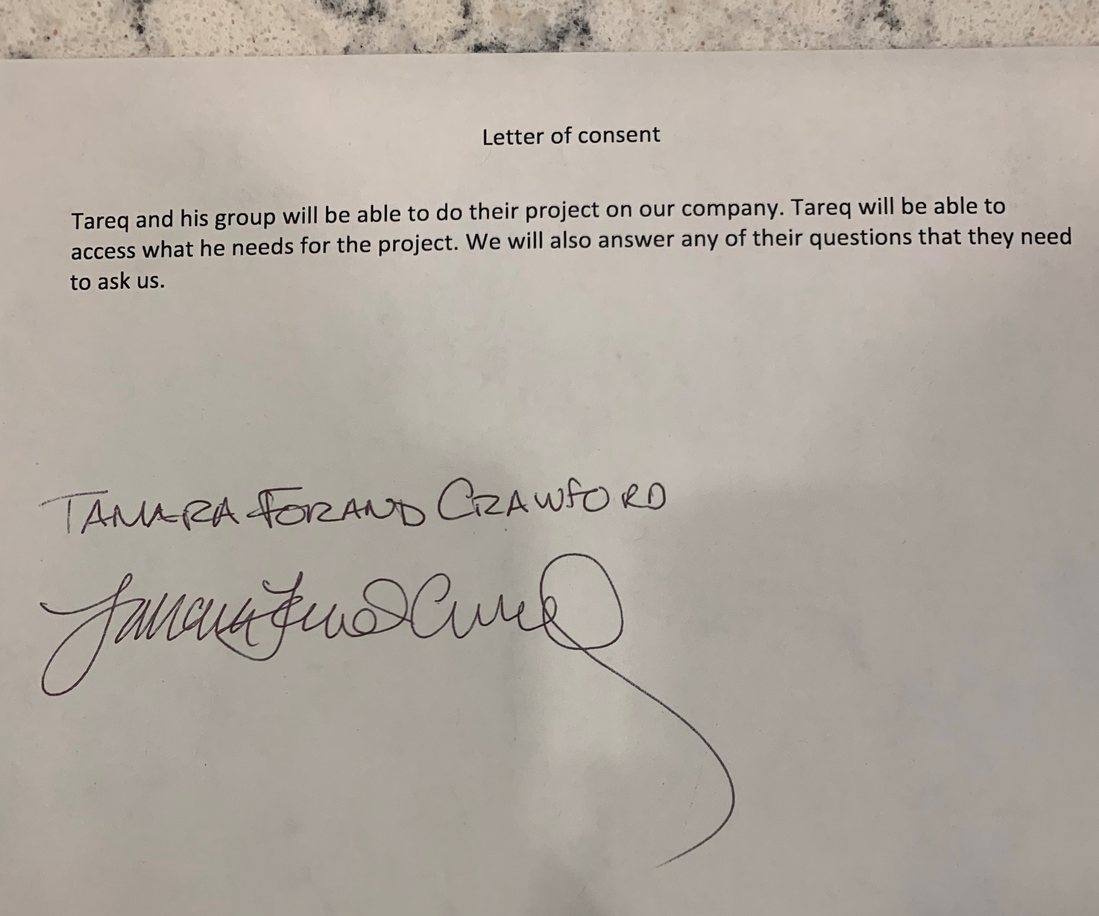

**Organizational Description**

**B-** David Hunter Homes is a local real estate company located in South Florida. The team is highly versed in the East Boca Market. Additionally, they work with clients on listings and acquisitions, from Jupiter to Miami, with impeccable attention to detail. Placing clients in their dream home is their number one priority.

**Organizational Chart**

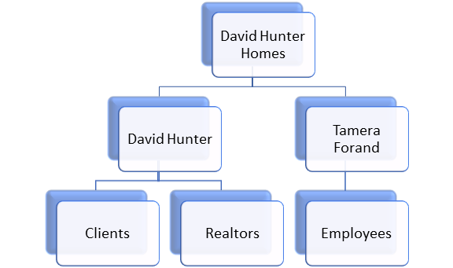

**C-** System Request

**Project Sponsor:** David Hunter and Tamara Forand.

**Business Need:** To facilitate their business and generate future growth, we’ll be implementing an interface between their Lead Generation System (ShowMojo) and their new ASP SAS CRM System.

**Business Requirements:** To improve compatibility between showmojo and ASP SAS CRM system.

**Business Value:** It will help hunter homes with being able to look at one system for end to end communications after they make first contact with their customers. They will be able to maximize their contact with their clients.

**Special Constraints:** As a result of budgetary constraints, our contract with David Hunter Homes is limited to three months, amounting to $12,000.

**D-** Feasibility analysis

**Technical Feasibility:**

* Improve end-to-end automation to facilitate their business process.
* Helping our potential clients find their dream homes.
* Scalability
* Maximize and Facilitate client interaction

**Economic Feasibility:** Our contract with David Hunter Homes amounts to a fixed fee of $12,000 (include training after implementation).

**Organization Feasibility:**

* Our key stakeholders are: David Hunter and Tamara Forand, Real Estate Agents, and potential clients.
* Maximize and facilitate client interaction.

**Schedule Feasibility:** Phase 1 & 2 will be done by March 19 and Phase 3 and presentation will be done by April 15.

**Preliminary Project Plan**

**Project Time Frame**

|  |  |  |  |  |
| --- | --- | --- | --- | --- |
|  | Planning | Analysis | Design | Implementation |
| Using standard Distribution | 23% | 22% | 29% | 26% |
| Estimates Based on system (Days-person) | Actual | Estimated: | Estimated: | Estimated: |
| Days total estimate | 21 | 25 | 26 | 23 |

**Work Breakdown Structure**

|  |  |  |  |  |  |  |
| --- | --- | --- | --- | --- | --- | --- |
| Work Breakdown Structure | | | | | | |
| Task ID | Task Name |  |  | Duration | Dependency | Status |
| 1.0 |  | Project Planning Phase | | 21 |  | Done |
|  | **1.1** | **Project Overview** |  |  |  |  |
|  |  | 1.1.1 | Meet Business Owners | 0.5 |  | Closed |
|  |  | 1.1.2 | Identify Business Needs | 1 | 1.1.1 | Closed |
|  |  | 1.1.3 | Identify Business Requirements | 1 | 1.1.2 | Closed |
|  |  | 1.1.4 | Identify special Issues/Constraints | 1 | 1.1.3 | Closed |
|  |  | 1.1.5 | Perform Technical Feasibility Analysis | 2 | 1.1.2, 1.13 | Closed |
|  |  | 1.1.6 | Perform Economic Feasibility Analysis | 2 | 1.1.2, 1.1.3, 1.1.4 | Closed |
|  |  | 1.1.7 | Perform Operational Feasibility Analysis | 2 | 1.1.2, 1.1.3 | Closed |
|  |  | 1.1.8 | Identify scope of Solution | 0.5 | 1.1.2, 1.1.3, 1.1.4, 1.1.5 | Closed |
|  | **1.2** | **Stakeholders** |  |  |  |  |
|  |  | 1.2.1 | Identify Stakeholders | 1 | 1.1.1 | Closed |
|  |  | 1.2.2 | Identify System Analyst | 0.5 | 1.2.1 | Closed |
|  |  | 1.2.3 | Identify PM | 0.5 | 1.2.1 | Closed |
|  |  | 1.2.4 | Identify Project QA | 0.5 | 1.2.1 | Closed |
|  |  | 1.2.5 | Identify Project Trainer | 0.5 | 1.2.1 | Closed |
|  | **1.3** | **Project Docs** |  |  |  |  |
|  |  | 1.3.1 | Identify Tasks | 2 | 1.1, 1.2 |  |
|  |  | 1.3.2 | Create WBS | 3 | 1.3.1 | Closed |
|  |  | 1.3.3 | Project Gantt Chart | 3 | 1.3.1 | Closed |
| 2.0 | Project Analysis Phase | | | 25 |  | In Progress |
|  | **2.1** | **Data Collection** |  |  |  |  |
|  |  | 2.1.1 | Fully Identify Stakeholders | 3 | 1.1, 1.2 | Open |
|  |  | 2.1.2 | Develop Interview Questions | 1 | 2.1.1 | Open |
|  |  | 2.1.3 | Interview Process Owners | 1 | 2.1.2 | Open |
|  |  | 2.1.4 | Observation of Current Process | 2 | 2.1.3 | Open |
|  |  | 2.1.5 | Feasibility Analysis | 13 | 2.1.3, 2.1.4 | Open |
|  | **2.2** | **Project Docs** |  |  |  |  |
|  |  | 2.2.1 | Data Flow Diagrams | 4 | 2.1 | Open |
|  |  | 2.2.2 | Project Gantt Chart | 1 | 2.1 | Open |
| 3.0 | Project Design Phase | | | 0 |  | Not Started |
| 4.0 | Project Implementation Phase | | | 0 |  | Not Started |

**Gantt Chart**

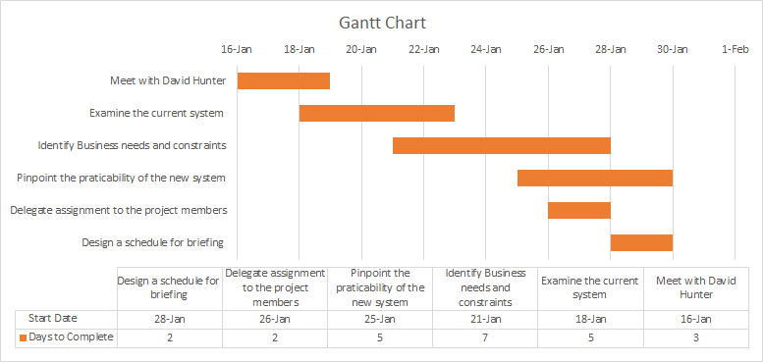**+**

**Staff Project**

|  |  |  |  |  |  |  |  |  |  |  |
| --- | --- | --- | --- | --- | --- | --- | --- | --- | --- | --- |
| **Name** | **Title** | **Business**  **Need** | **Business**  **Requirements** | **Project**  **Scope** | **Feasibility**  **Analysis** | **Identify**  **Potential**  **Solutions** | **Manage**  **Project** | **Staff**  **Project** | **Testing** | **Training** |
| **David**  **Hunter** | **Project**  **Sponsor** | **A,R** | **A,R** | **A,R** | **A,R** | **C** | **C** | **C** | **C** | **C** |
| **Tareq**  **Kadamani** | **Project**  **Manager** | **C** | **C** | **C** | **C** | **A** | **A,R** | **A,R** | **A** | **A** |
| **Jean Viaud** | **Project**  **Trainer** | **I** | **I** | **I** | **I** | **I** | **I** | **I** | **I** | **R** |
| **Anthony**  **Wilson** | **Project –**  **BA** | **C** | **C** | **C** | **C** | **R** | **I** | **C** | **C** | **C** |
| **Nguyen**  **Tran** | **Project-**  **QA** | **I** | **I** | **I** | **I** | **I** | **I** | **I** | **R** | **I** |

|  |  |
| --- | --- |
| **RACI LEGEND** | |
| **R** | **Responsible** |
| **A** | **Accountable** |
| **C** | **Communicate** |
| **I** | **Inform** |

**Team Charter**

**Team Purpose**

Team 2, composed of 4 members, will assist in building an interface between their Lead Generation System (ShowMojo) and their new ASP SAS CRM System. We will be writing this program to act as a bidirectional metafilter between the two sas system.

The lead generation component syndicates to over 25 different real estate sites. This project will allow them to grow their business and better manage their clients after they have initiated contact. Most specifically the interface will allow their 2 systems to talk and provide end to end automation for their business.

**Duration and Time Commitment**

Team 2 will work with until the end of the Spring 2019 Term. By the end of this term, we will have completed the first three phases of the System Development Life Cycle; Planning, Analysis, and Design. Team 2 will not support through the implementation and post implementation phases, Team 2 will have provide all of the necessary information for those phases.

**Scope**

Team 2 will work David Hunter Homes with to create an interface between their Lead Generation System (ShowMojo) and their new ASP SAS CRM System. At the end of the third phase we will have written a program that will help automate their business.

**Members**

|  |  |
| --- | --- |
| David Hunter | Project Sponsor |
| Tareq Kadamani | Team 2 - Project Manager |
| Anthony Wilson | Team 2 - QA |
| Jean Viaud | Team 2 - Trainer |
| Nguyen Tran | Team 2 - BA |

**Desired End Result**

This program will allow to grow their business and better manage their clients after they have initiated contact. Most specifically the interface will allow their 2 systems to talk and provide end to end automation for their business.

**Supporting Resources**

David Hunter Homes will be available to interview with Team 2 in order for Team 2 to understand their needs and current business processes. David Hunter Homes will need to provide a 2-3 hours a week to work with Team 2.

**Reporting Plan**

Team 2 has been divided into 4 different roles. Members of the team will perform assigned tasks and communicate their progress to the PM.

**D-** Control and Direct Project

**Project Standards**

**Code of Conduct:** The members of the team are expected to conduct themselves with the highest degree of honesty, integrity and ethics and within the confines of the law, university’s code of conduct when acting on behalf of the team.

**Documents Standards:** All documents shall be uniformly presented, grammatically sound, and well organized.

**Procedural Standards:** Every week (preferably every Tuesday), we’ll discuss the project needs, assign tasks, address issues or concerns either in person or via the various methods of communication available.

**Coding Standards:**  We will be implementing a dynamic program with functional components to act as a bidirectional metafilter between the Lead generation system and the SAS system.

**Requirements Standards:** With the implementation of the interface, it will optimize the system, improve scalability, and improve end-to-end automation to facilitate their business process.

**Risk Assessment**

**Risk:** As a result of the implementation of the new system, unfamiliarity with the new system may lead to a drop in revenues.

**Likelihood of Risk:** High

**Ways to address the risk:** To mitigate the aforementioned risk, implementing a series of training videos will surely facilitate familiarity with the new system, which as a result would increase business.

**E-** Preliminary fact-finding

**Potential Interview Questions**

On average, how many showings does the company have in a week?

How efficient is the current appointment scheduling process?

Does the work breakdown structure highlights the critical paths needed for repeatable business?

Where does this process start? What are the steps needed to implement this feature?

What outside resources will be necessary?

What needs to be tracked? (Click Through rate, Click Tracking, Click Heatmap)

What problem is this business having that you hope to solve by developing this project?

How will you use this feature?

How can we meet this business need?

What does this feature need to do?

What is the end result of doing this?

**Similar Systems**

* Zillow
* Trulia
* HomeFinder
* Realtor.com
* RedFin
* MLS.com
* Century 21
* REMAX
* Homes.com
* Keller Williams Realty
* RentCafe

Phase 2 - Fact Finding

ISM 4133 ADVANCED SYSTEMS ANALYSIS AND DESIGN - GROUP PROJECT

**A-**

I. Key Stakeholders

The primary key stakeholders are all parties that will be affected or benefited as a result of the implementation of the new system.

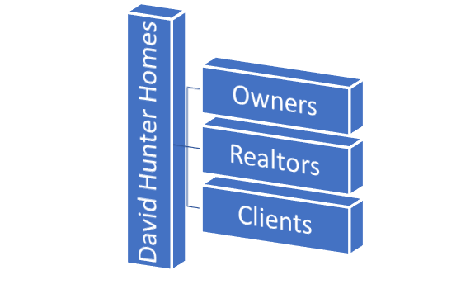

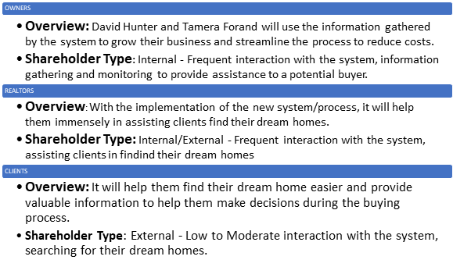

II. Interview Questions

To gather more information about the current system and the desired result of the new system, a list of questions was sent to the owners, David Hunter and Tamera Forand.

|  |
| --- |
| Interview Questions |
| On average, how many showings does the company have in a week?  **Answer:** On Average, we have 6 showings with an average of 12 potential clients.    How efficient is the current appointment scheduling process?  **Answer:** We are a small company; our current appointment scheduling process works for us but feel free to improve upon it.    What outside resources will be necessary?  **Answer:** ShowMojo, ASP SAS CRM System passwords, and data from multiple listing sites and popular products such as Zillow, Trulia, Buildium, Propertyware.    What needs to be tracked?  **Answer:** We would like to be able to track certain performance usage such as latency, click through rate, click heatmap, and click usage.    What problem is this business having that you hope to solve by developing this project?  **Answer:** We hope to increase our business needs by improving on the current process by giving the client more power and reduce the buying process with the implementation of the new system.    How will you use this feature?  **Answer:** To better serve our client and improve the buying process which as a result would empower our client by giving them the option to take over the majority of the buying process such as giving them the ability to search for their dream home directly.    How can we meet this business need?  **Answer:** We simply need our system to communicate with ShowMojo, and giving our clients the power to search for their dream home with our new implemented system by gathering, importing, and update listings from almost any listing sites.    What does this feature need to do?  **Answer:** To facilitate the end to end automation between ShowMojo and our current system.    What is the end result of doing this?  **Answer:** Facilitating the buying process, increase our business and reduce costs.    How much money are you looking to invest to implement this new system?  **Answer:** We are looking to invest roughly about $20,000, $10,000 for the analysis team and $10,000 for the development team. |

III. Detailed Observation of Existing Work Process

The customer sends in a lead from one of the 25+ real estate websites they post on. Then ShowMojo alerts David and Tamera that there is a lead for them to contact. They look at what property they are interested in and David contacts the customer and sees when they can see the property and if they are interested in seeing other properties in their needs also. Tamera then logs it in ASP SAS CRM System while David is on the phone and then she gets on the phone to schedule the showing. The day before the showing Tamera gives the customer a call to confirm the showing. The day of the showing David goes to the property early to get the keys and gets ready to show the property. The customer shows up and David shows them everything in the property and if they love the property he will get them to sign the contract on the property. If they wanted to see more properties he goes and shows them those property.

After the customer is satisfied and signed to a property they log everything such as move in and move out and get a notification 60 days before move out and they contact the customer to see if they want to resign where they currently live or if they want to move out so they can help them find a new place and keep the customer satisfied and repeat this process for all their customers.

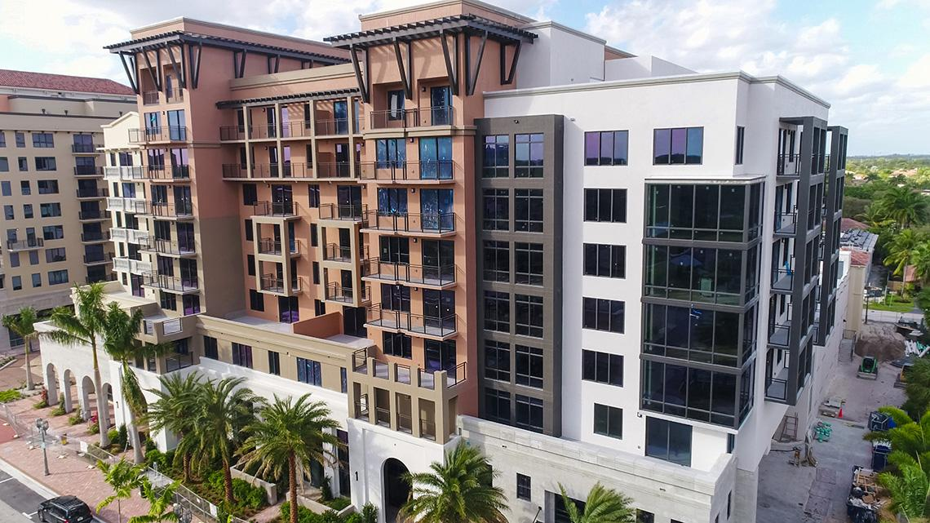

**B-**

IV. Feasibility Analysis

David Hunter Homes is a small company, due to their limited budget and resources, we hope to increase their business by implementing a bi-directional filter to improve the end to end automation between Showmojo and the ASP SAS CRM system. To achieve that feat, we would be gathering data from multiple listings sites by web scraping those listing sites. Using the website API services, the development team will write a custom script to query and get the API response, and extract the data from those listing sites.Moreover, we want to build this feature by implementing a framework that interfaces with both system to reduce manual input to minimize errors and using said framework to establish communication between the two systems, thus, improving the entire process.

In terms of economic feasibility, we hope that with the implementation of the new system to double David Hunter Homes’ annual revenues in the next three years.

David Hunter Homes Annual Revenues : **$150,000**

Project Cost: **$20,000**

We hope to increase revenues by 15% in year 1:

**Year 1 = 150,000 * 15% = 22,500**

By 25%, the next year:

**Year 2 = (150,000 + 22,500) * 25% = 43,125**

By 50%, the year after:

**Year 3 = (150,000 + 22,500 + 43,125) * 50% = 107,813**

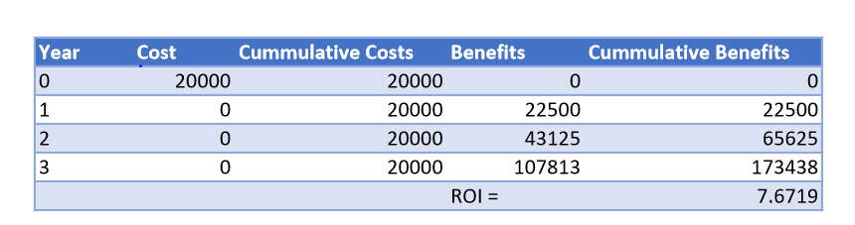

By the end of year two post-implementation, the company’s annual revenue will have increase by 173,438  **(22,500 + 43,125 + 107,813 ),** which would satisfy our post-implementation projection estimates **(Current Annual Revenue: 150,000 + Cumulative benefits of new system: 173,438 = 323,438).**

**C- Data Flow Diagrams**

V.Context Diagram

The context diagram shows a high-level view of the entire buying/ leasing process.

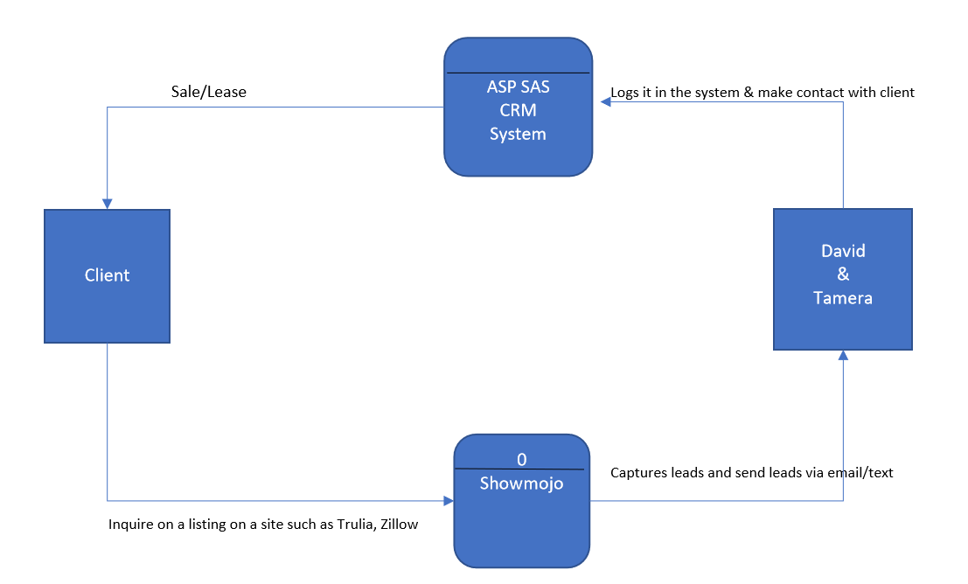

VI. Level 0 Diagrams

A detailed diagram of the current buying/leasing process.

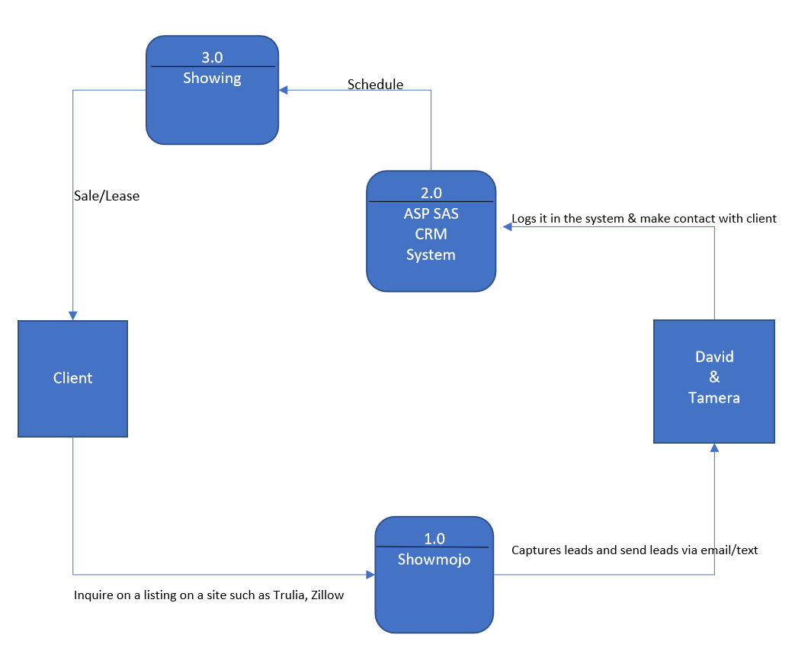

VII. Level 1 Diagram

A detailed view of the new system with the implementation of the filter.

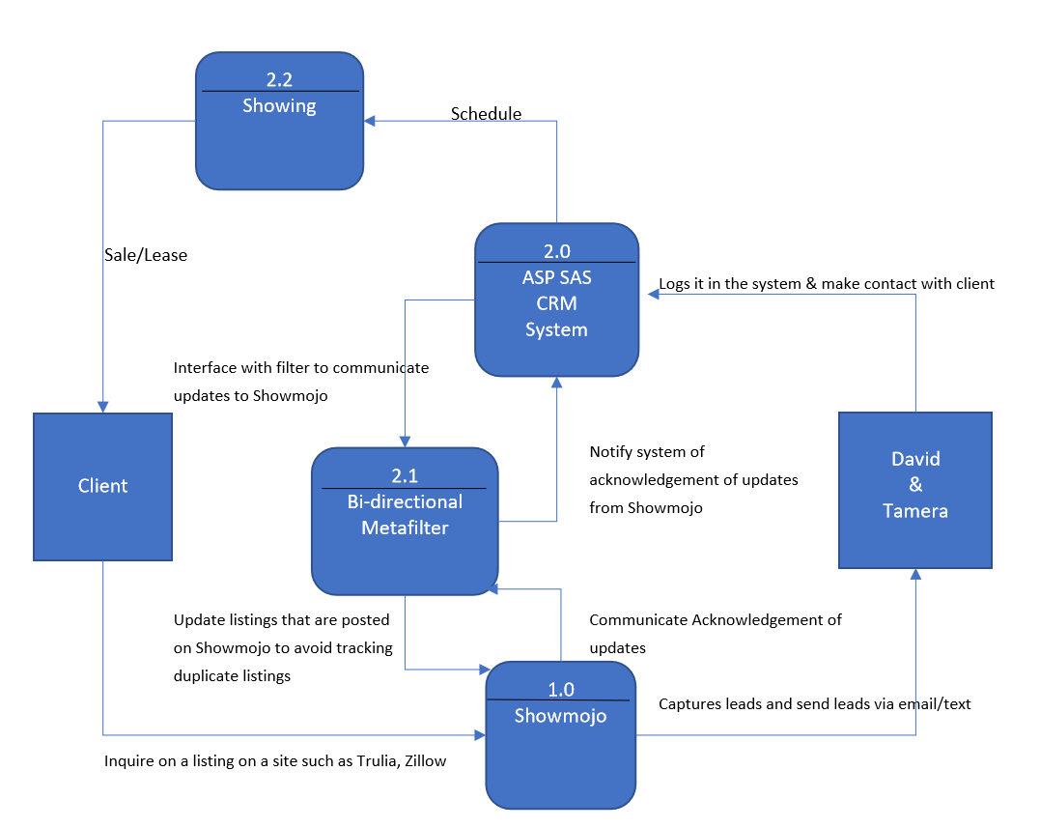

**D-**

VIII. Use Cases

The use cases below show the processes that produce the output results. A trigger event is needed in order to initiate the actions performed by David Hunter Homes.

|  |  |
| --- | --- |
| Use Case Name: | Agreement to sell homes |
| Actors: | Agent, Homeowner |
| Brief Description: | In order to sell homes, David Hunter Homes needs homeowners to agree to allow agents to sell their homes. |
| Triggering event: | David Hunter Homes needs homes to sell. |
| Pre-conditions: | 1.Homeowner needs to get home appraised  2. Agent needs to determine if home is worth looking into  3.Homeowner needs to agree to agent fees |
| Normal Course: | 1. Customer gets home appraised  2. Customer agrees or declines to move forward will sale  3. Agent begins to look for potential sale |
| Post-conditions: | Appraisal becomes available for all potential buyers |
| Exception Conditions: | 1. Homeowner doesn’t like the appraisal and wants to wait for sale 2. Agent doesn’t believe home is worth trying to sell |

|  |  |
| --- | --- |
| Use Case Name: | Homeowner agrees to sell |
| Actors: | Agent, Homeowner, Home buyer, Bank |
| Brief Descriptions: | Both homeowner and the home buyer agree on the sales price. |
| Triggering event: | Home buyer makes offer, and homeowner agrees to said offer. |
| Pre-conditions: | 1. Home buyer inspects house and negotiates price willing to pay  2. Home owner and agent discuss possible counteroffers |
| Normal Course: | 1. After reviewing offer, home owner and agent agree to deal  2. Proper legal processes, including filling out paperwork and financing agreements are signed off on. |
| Post-conditions: | Home buyer gets title of house. |
| Exception Conditions: |  |

|  |  |
| --- | --- |
| Use Case Name: | Homeowner declines sale |
| Actors: | Agent, Homeowner, Home buyer |
| Brief Description: | Homeowner/Agent doesn’t like the selling price that the potential home buyer is offering. |
| Triggering event: | Offer wasn’t sufficient. |
| Pre-conditions: | Offer was lower than homeowner/agent was willing to agree to. |
| Normal Course: | Homeowner and agent discuss and decide to decline original offer. |
| Post-conditions: | Counter-offer is possibly made to see if home buyer is willing to pay more. |
| Exception Conditions: |  |

E-

IX. Functional Decomposition Diagram

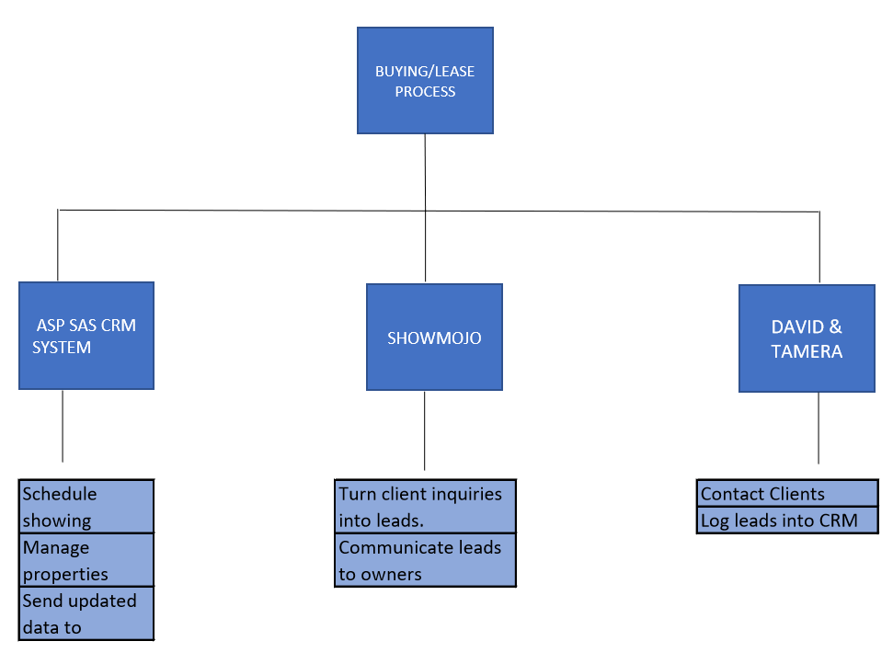

**F-**

X. Entity Relationship Diagram

We created a one-to-many relationship diagram to show the correlation between the client, properties that are being tracked and the leads associated with it.

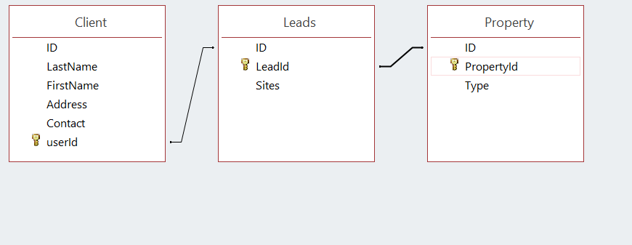

**G-**

XI. Gantt Chart

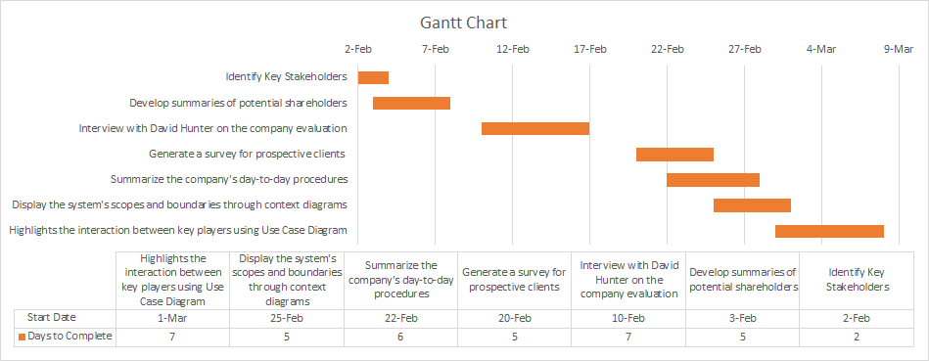

.

Phase 3 - System Design

ISM 4133 ADVANCED SYSTEMS ANALYSIS AND DESIGN - GROUP PROJECT

A- System Acquisition Strategy

Alternative Matrix:

Below is an alternative matrix, which I will use to compare and contrast the different solutions that will be added to David Hunter Homes. The system that results in the highest score will be the best option. After analyzing the matric, the newer system we designed will be the best option for David Hunter Homes.

|  |  |  |  |  |
| --- | --- | --- | --- | --- |
|  | Old System | | New System | |
| Criterion | Weight | Score | Weight | Score |
| Cost | 5 | 3 | 8 | 7 |
| Efficiency | 7 | 3 | 10 | 8 |
| Development Time | 3 | 3 | 3 | 2 |
| Integration | 5 | 4 | 5 | 4 |
|  |  |  |  |  |
| Total Score: | 20 | 13 | 26 | 21 |

B- Designing the environment

David Hunter Homes deals a lot with connecting its clients with other businesses, by referrals and end to to end services, on top of the main function of selling homes. Daily operations require access to computers and a network of communication between clients and agents, as well as creating a link between clients and the right service provider for their needs. The only computers needed will be the ones that the agents will be using. With our system agents will be able to find the up-to-date listings from all the top websites. There will need to be a good wireless internet connection to ensure a smooth experience during use. The agent will be able to see listings offline, but the listings that are pulled off will be only as up to date as the last time it was updated online. Dave Hunter Homes will be able to integrate this system on any operating system, and all the routers, firewalls, computer servers, and computers are already set up and ready to go.

C- Designing the application structure

This is a window-based system. It should have 2 different view layers. The two different layers are broken up into view layer and data layer.

* The view layer will display and accept user input and output.
* The data layer keeps all the information needed such as employee, client name…







User Request Formatted Response

|  |
| --- |
| View layer |
| User Interface components |
| User interface process components |



Info request

Formatted

Response

|  |
| --- |
| Domain & Data Layer |
| Business Rules |
| Business Workflow |
| Data Components |
| Data Stores |

For this system we will use four subsystems. The first subsystem category is employee and it will contain: employee, username, password, contact information. The next category is client and that will contain: client name, client email, client phone number, client interest. The other category is schedule and that contains: clients, schedule, showing time, showing location. The last category is listing which contains: listing, showing, leads, client information.

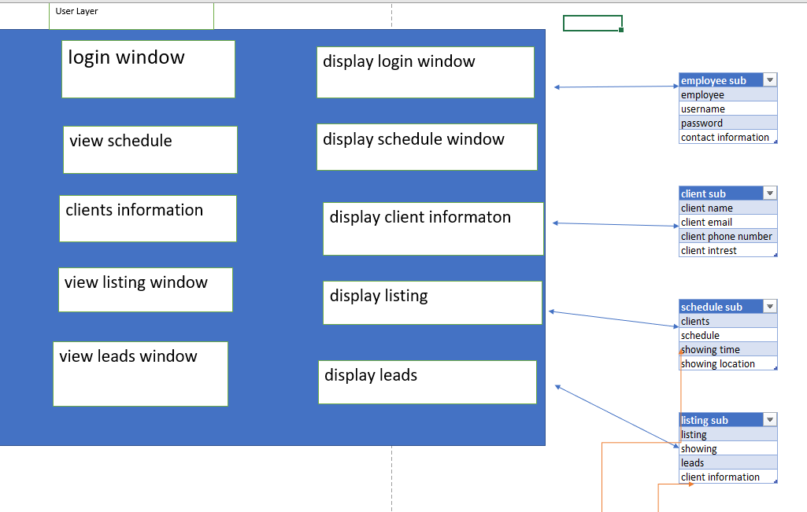

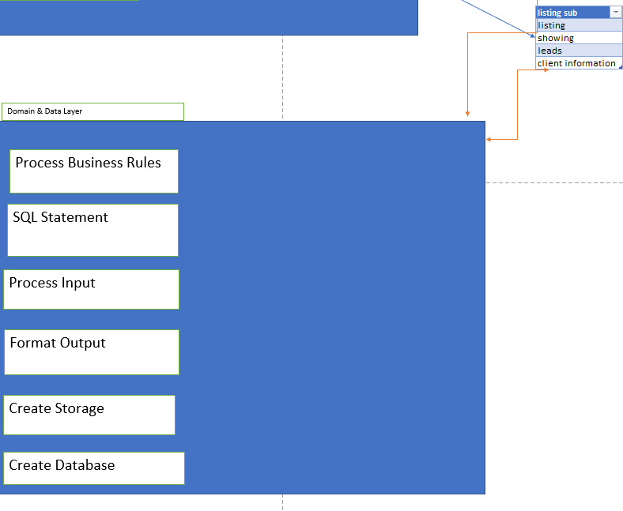

D - Designing the user interface

1. User Interface Design

The figure below shows a rough draft of the user interface on the new system.

1. The login page for the ASP SAS CRM system

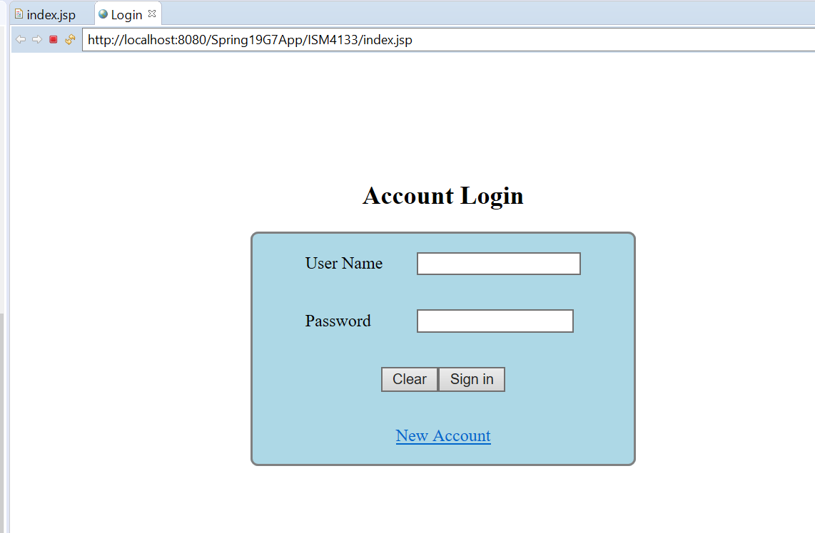

2) A page to input leads that they received from Showmojo

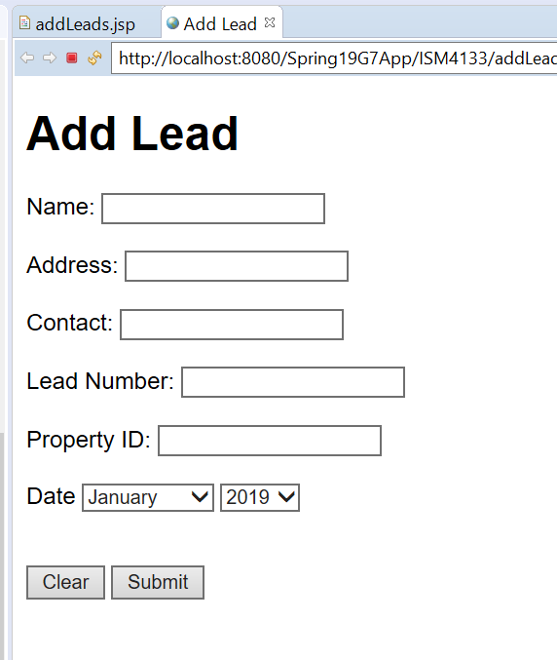

II. Storyboard Design

The implementation of this feature is internal, therefore, a dialog is not applicable.

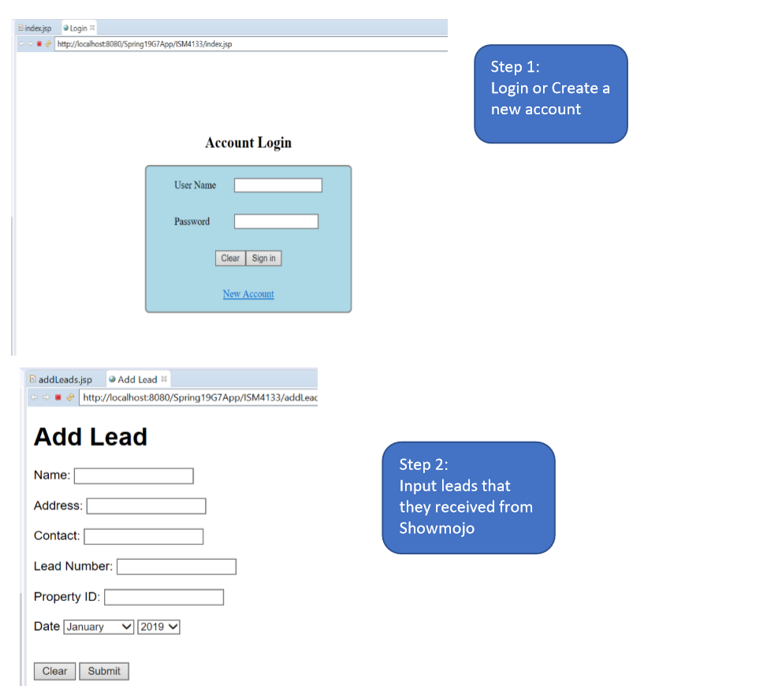

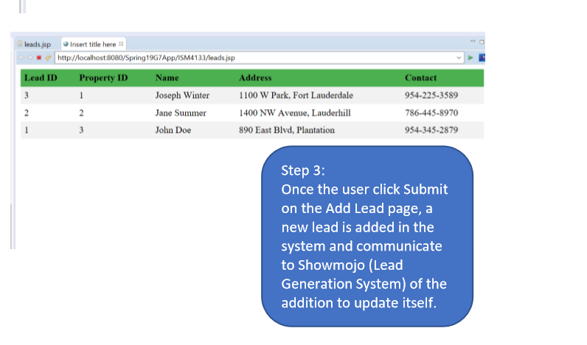

III. Input and Output

1. Input



|  |  |  |
| --- | --- | --- |
| Type of Validation | Applicable | Example |
| Completeness: **Ensures that all required data has been entered** | When several fields must be entered before the form can be processed | Before moving onto the next step all the information needs to be filled out |
| Format: **Ensures that data are of the right type** | When fields are numeric | The data in the fields should match the format and be checked |
| Range: **Ensures that numeric data are within correct limit** | With all numeric data | Ensure that the numbers being entered are between correct values |
| Check digit check: Check digits are added to numeric codes | When numeric codes are used | Digit checks are numbers added to a code to quickly confirm correctness. |
| Consistency: **Ensure that combinations of data are valid** | When data are related | Separate fields should be available for related data to avoid confusion |
| Database: **Compare data against a database to ensure accuracy.** | When data are available to be checked | Data inputted should be able to cross-reference information to ensure that there is no inconsistencies. |

2) Output

Example: Summary Report of all leads

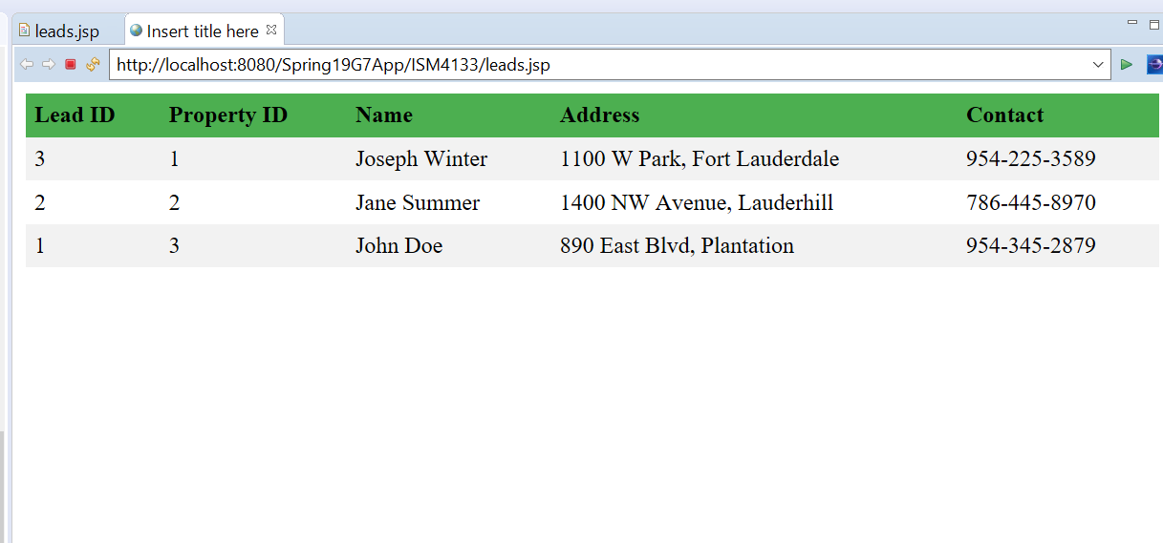

3) Report Design



E- Software/Program Design

1. **Application Software Logical Design**

Although we are focusing on the buying/lease process, this is a high level view of the application logical design which starts with client inquiries on a listing on a real estate sites such as Zillow, which is tracked and recorded by Showmojo(Lead Generation System) where every inquiry is turned into a lead to be entered into the CRM system. Afterward, the client is contacted to schedule showing, then, negotiations and if everything goes well a sale is made or a unit is leased. After the buying/lease process, a new owner account is created to manage the property and perform administrative duties such as sending out move in/out confirmation details, process payment, and other relevant communication. Lastly, the owner can also make service request, make payment, and other relevant tasks.

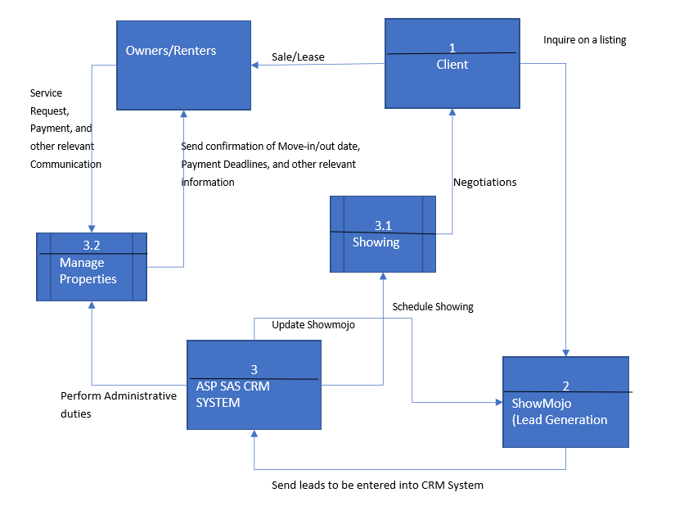

1. **Structured Charts**
2. Interface Structure Design for ASP SAS CRM System for the addition and the monitoring of leads during the buying/lease process.

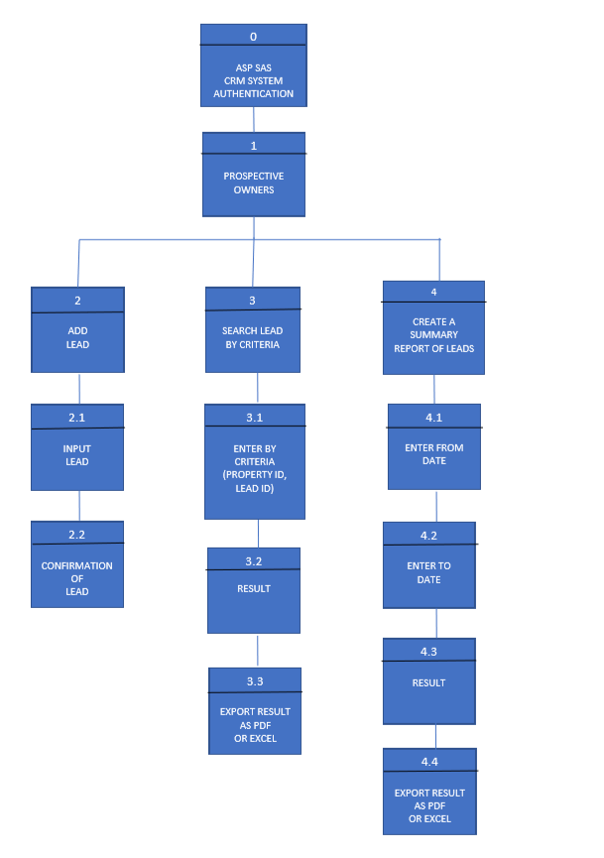

1. **Program Specification**

**Unit: 1**

**Name:** Build tables on the company server

**Purpose:** Store leads and to retrieve data

**Events:** Entering leads in the system

**Input:**

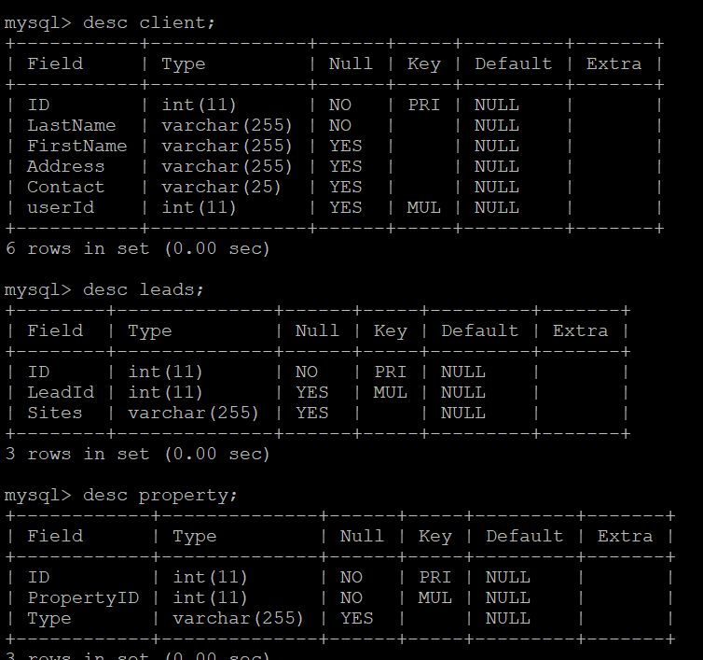

**Output:**

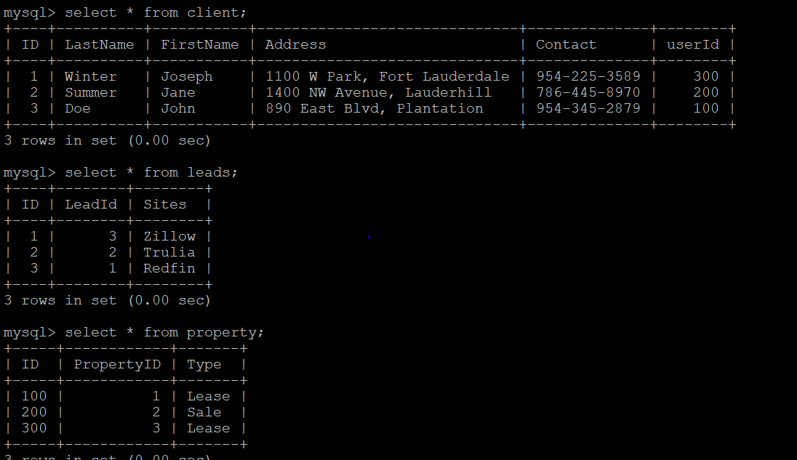

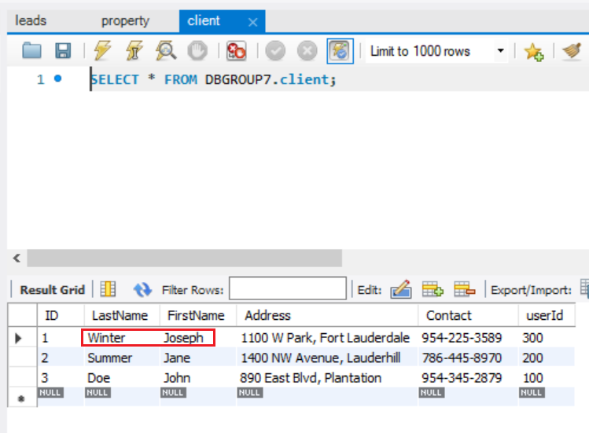

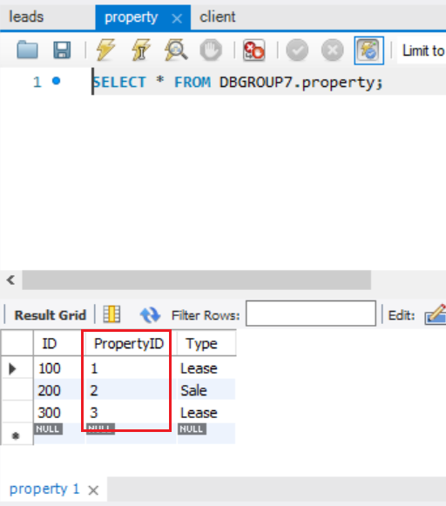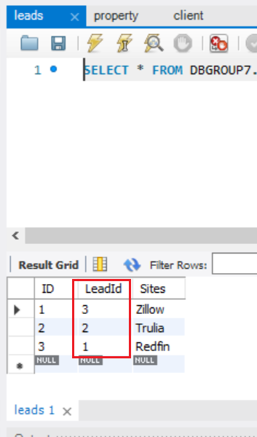

**Unit 2**

**Name:** ASP SAS CRM SYSTEM login page

**Purpose:** Authenticate user

**Event:** Sign-in or Create a new account



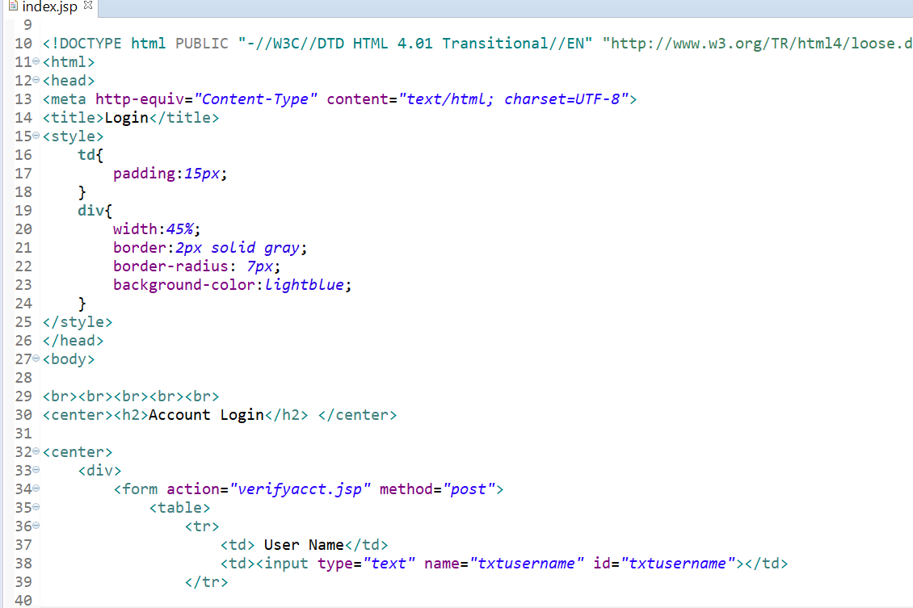

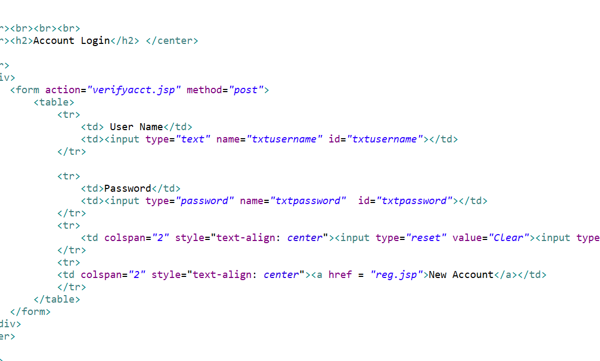

**Unit 3**

**Name:** Add lead page

**Purpose:** Record lead in the system

**Events:** Enter a lead



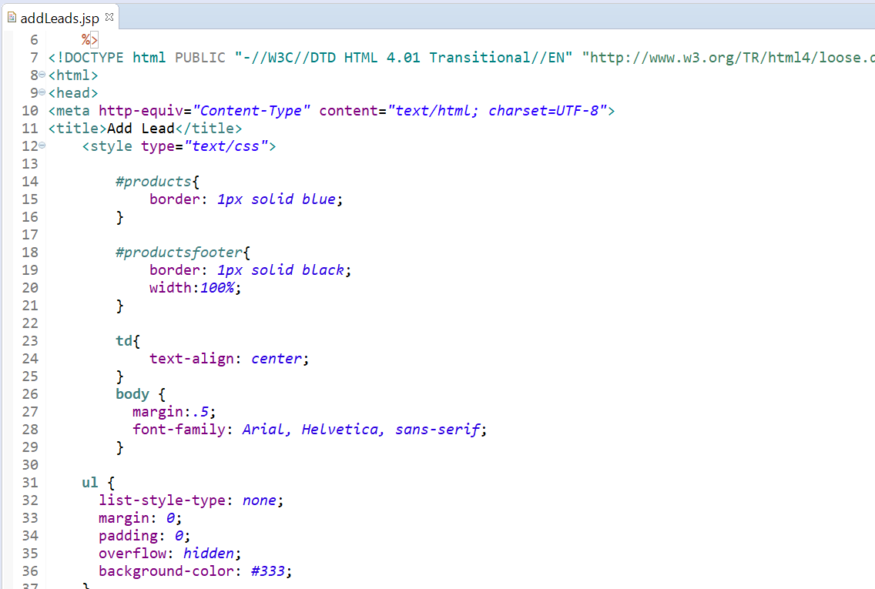

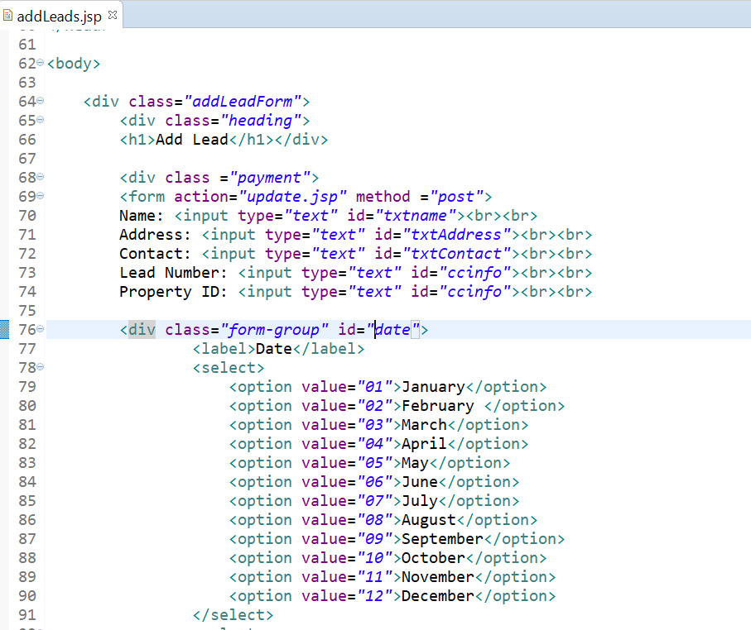

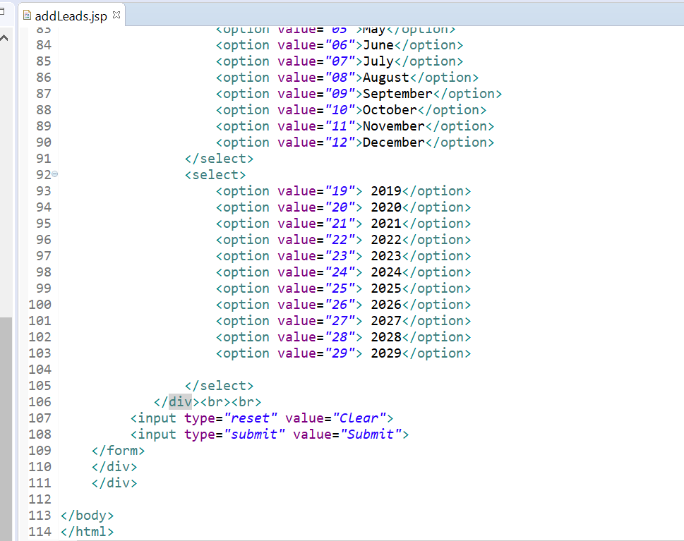

**Unit 4**

**Name:** Summary of all leads

**Purpose:** Access & Retrieve leads

**Events:** Create a report of all leads



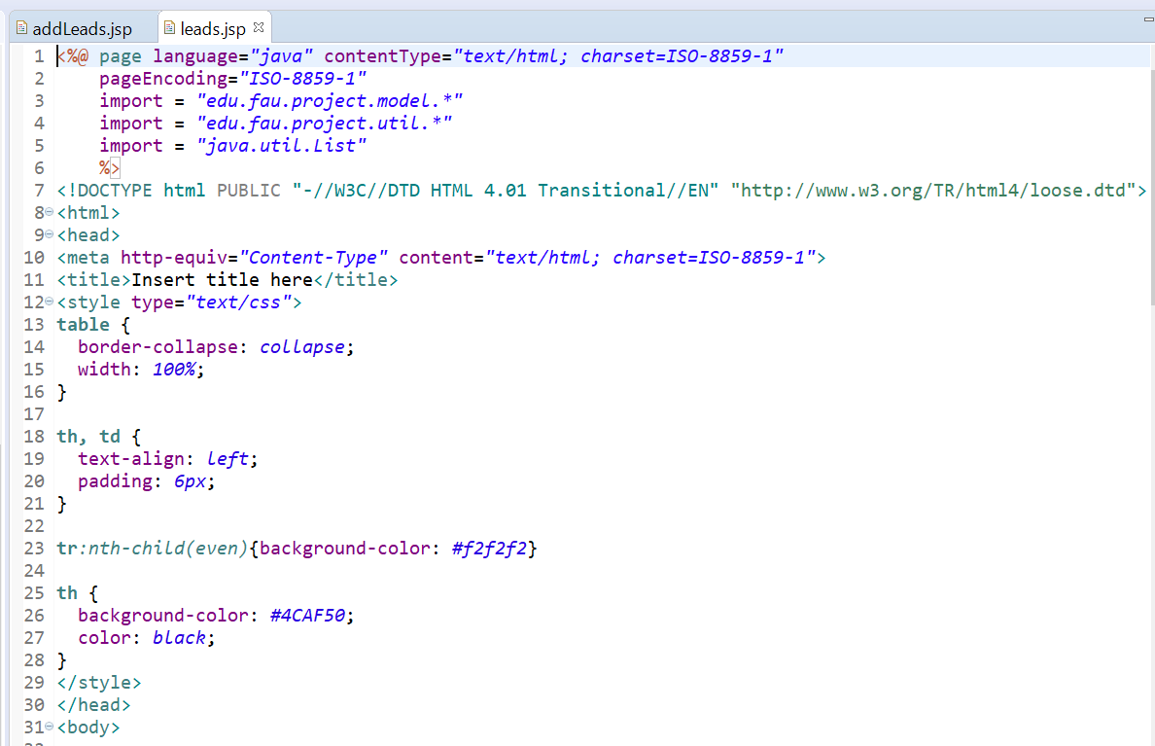

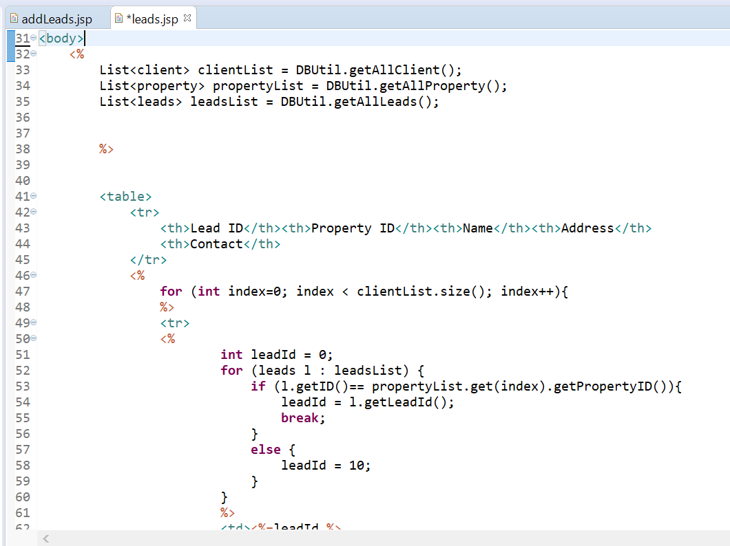

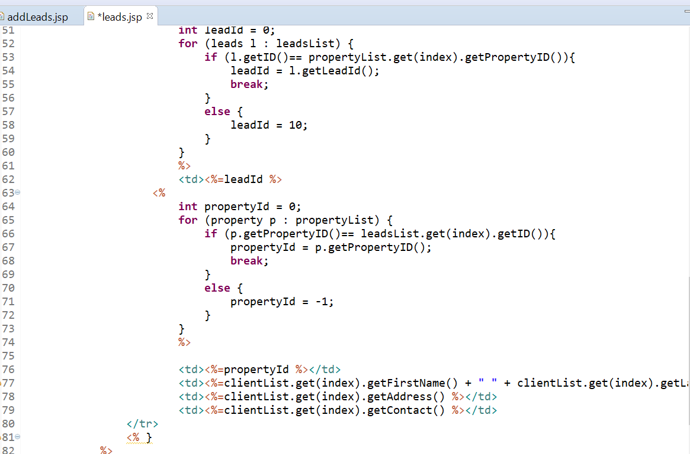

1. **Pseudocodes**
2. DBUtil

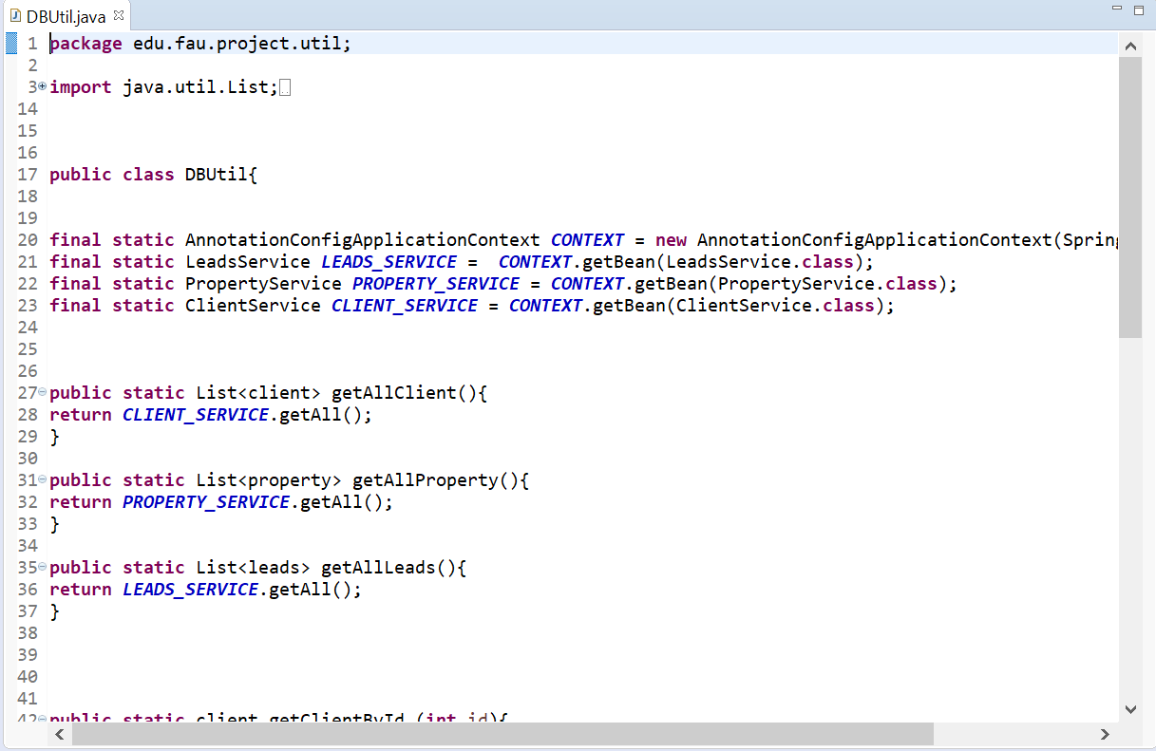

1. Client.java

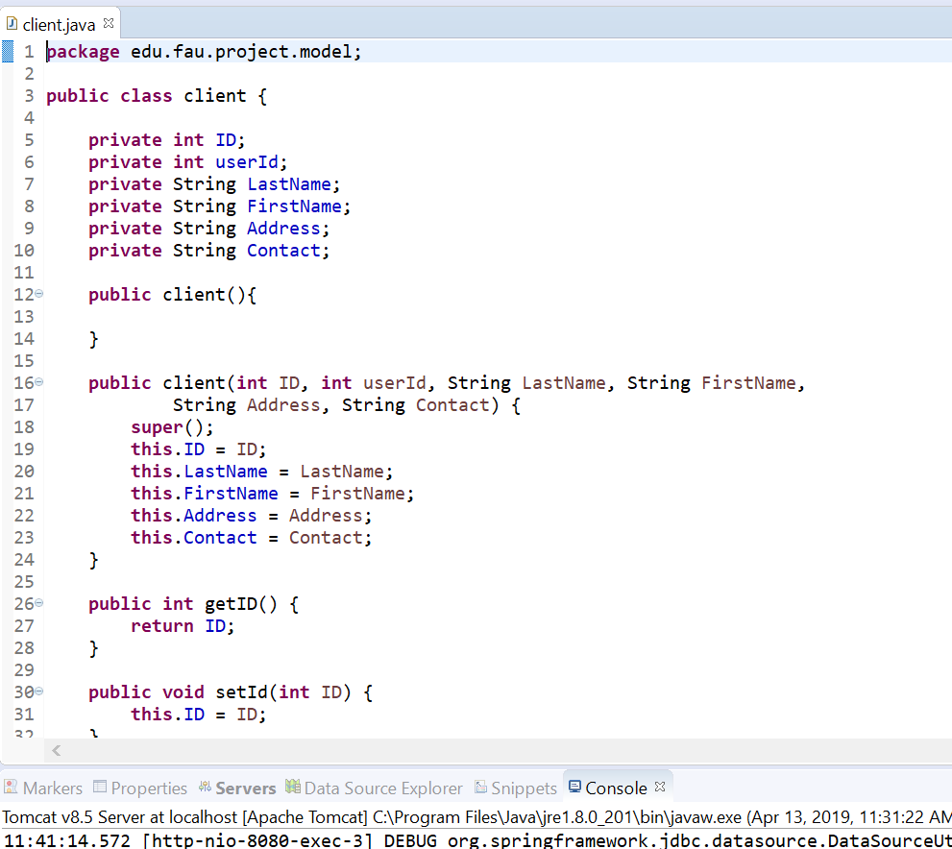

1. leads.java

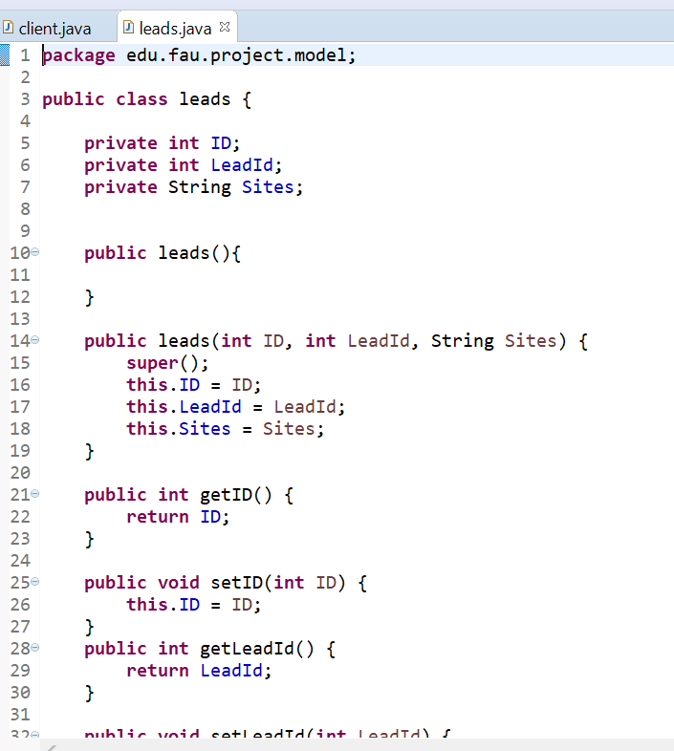

1. Property.java

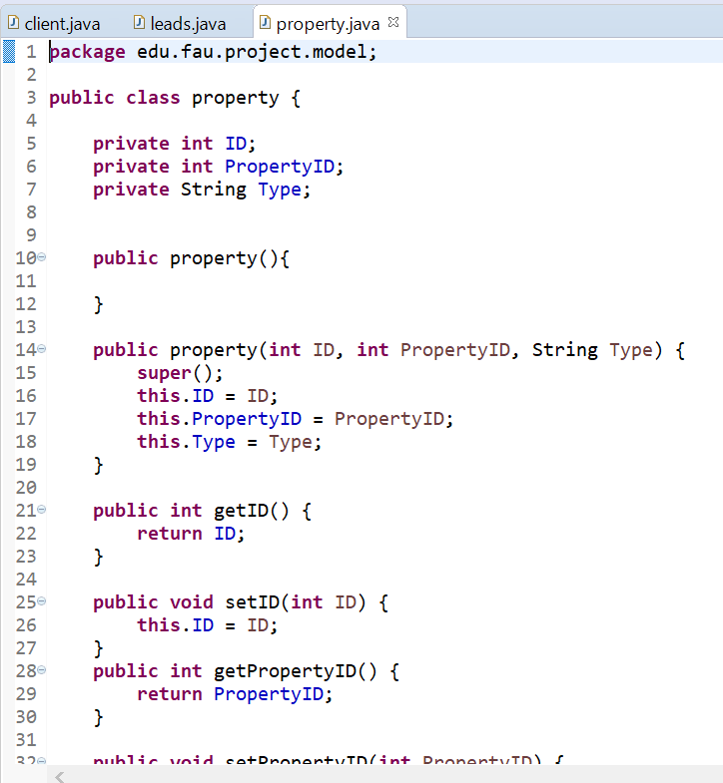

5) Base Service

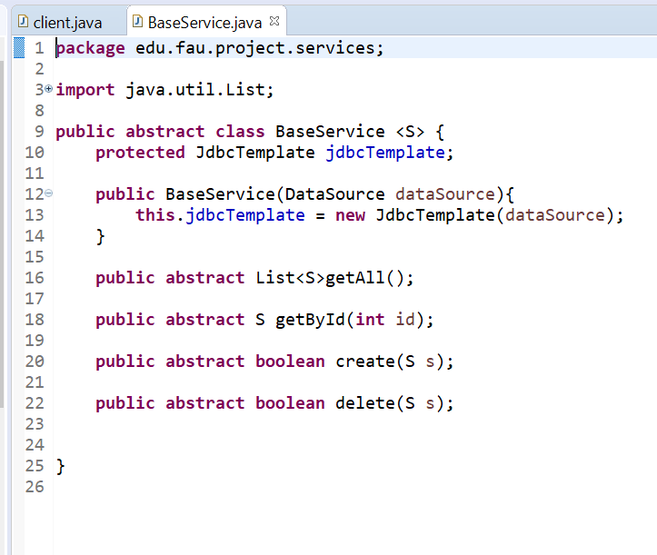

6) Client Mapper

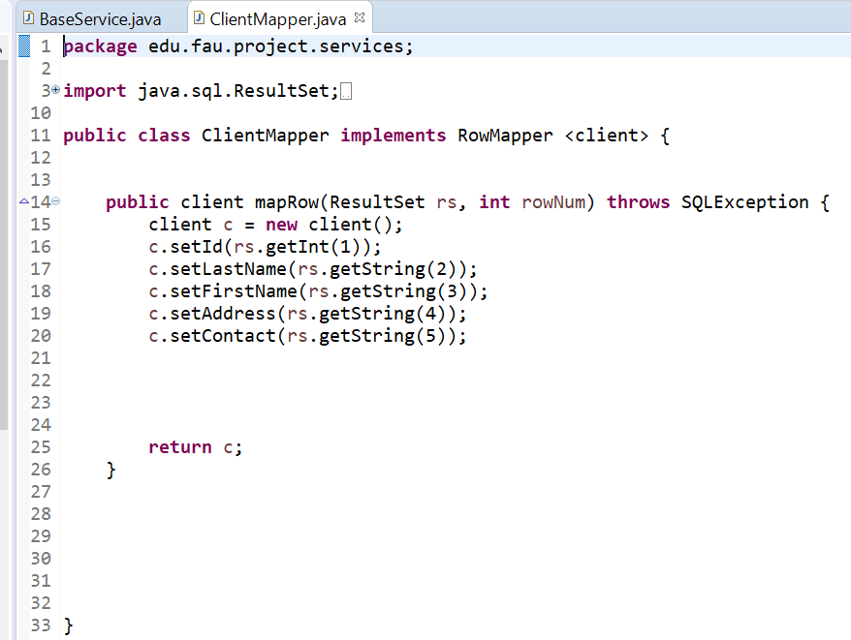

7) Client Service

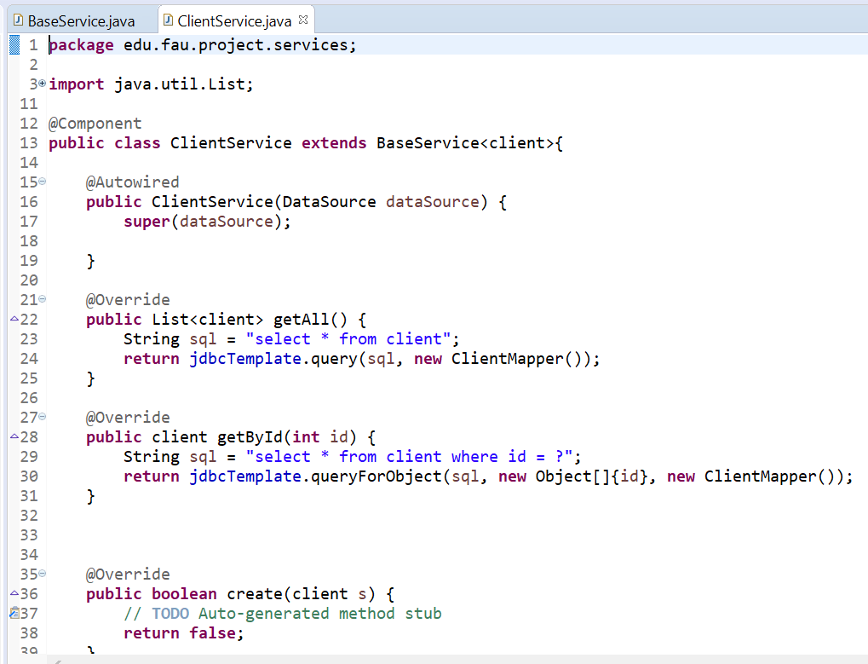

8) Leads Mapper

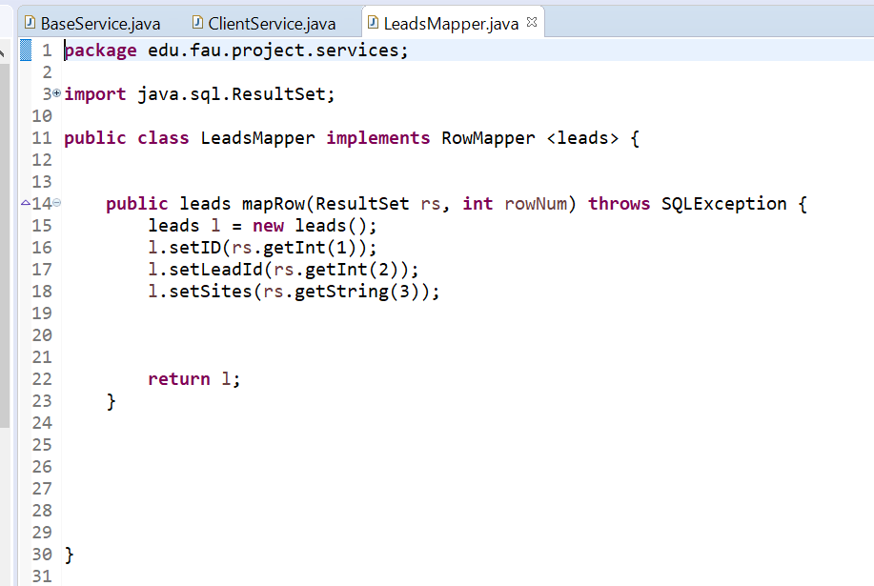

9) Leads Service

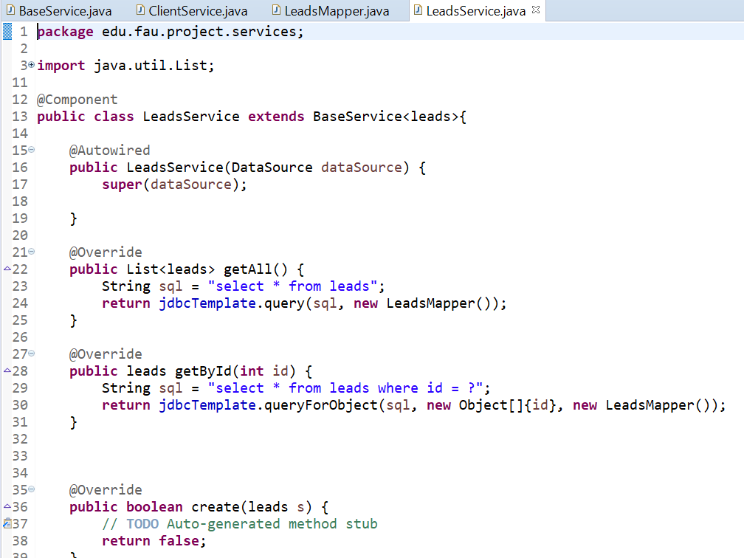

10) Property Mapper

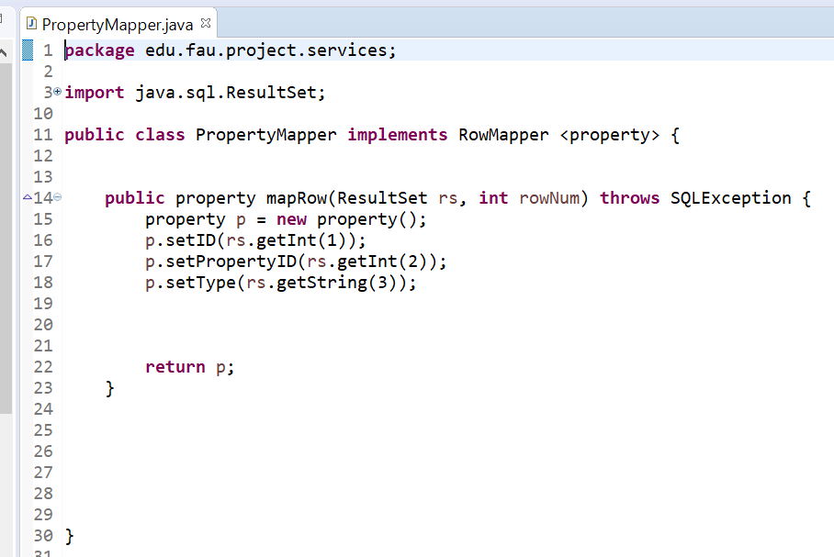

11) Property Service

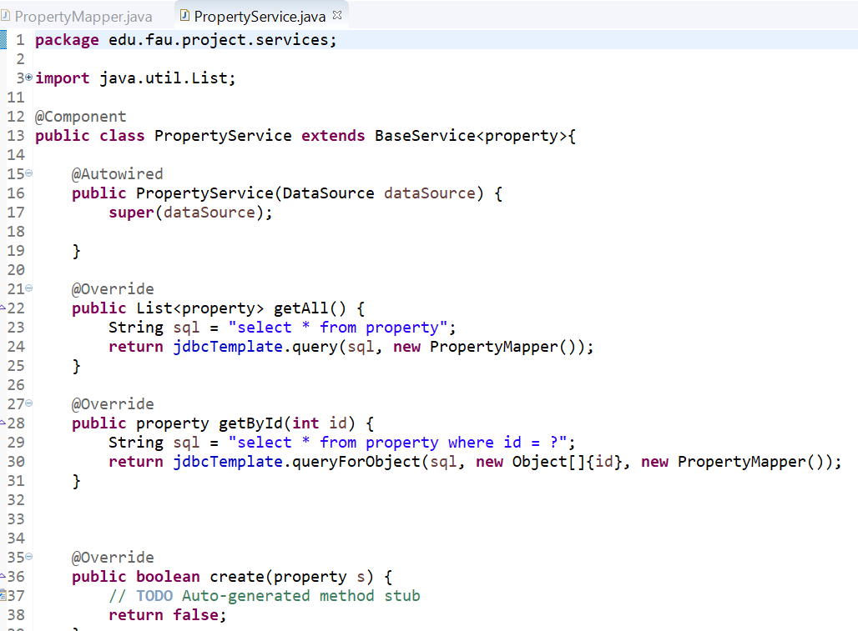

1. Login page





2) Add lead page







3) Summary of leads page







F- Designing the database control & security

**V. Gantt Chart**

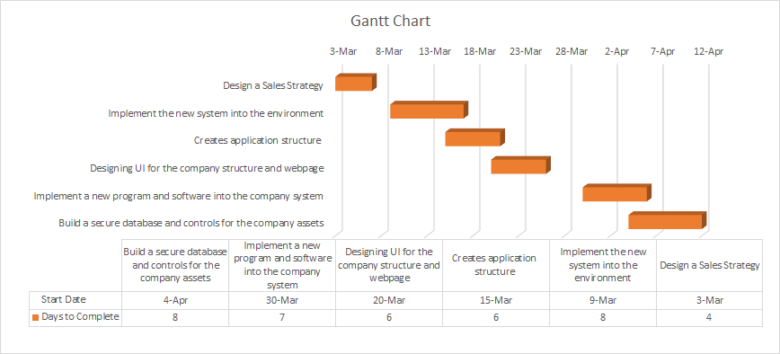

**F. Designing Database and Control security**

**I) Input Control**

Once the user profile have added their profile through the “Add Lead” database, they can easily access with their personal information through the tab of Housing Profile. The figure below shows a straightforward way where the user can select their type of residence and began search for their individual housing profile by filling in the information that was used to sign up with in the database at the beginning. The users also have the option to select the real estate agent that helped them with the registration process to narrow down the search criteria. Any “HTTP 404” error that arises would be most likely due to human errors. Where the formats and restriction imposed upon the information that is enter into the parameters was set in the database (SQL). The system should not take more than 5 second to pull up the respective information to the user inputs.

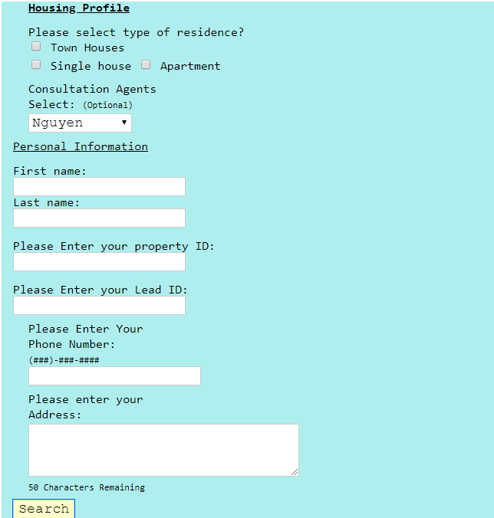

**II) Output Control**

If the user enter the correct input within the parameters, the following information should pop up on a page in the image below. If not, a “HTTP 404” error message will execute on a webpage. The user can always revert to the housing profile page to re-enter their information. The system should not take more than five seconds to pull up the page below.



**III) Security Controls**

Every employee within the company would have to log into the portal of Microsoft Sharepoint Online with their credentials to view their schedule, employee benefits, yearly W-2 Tax statements. Without a company credentials, no one else will be allowed to log in to view the company or private individual information. David Hunter Homes will also partner with VMware to provide intrinsic security & intelligent protection to their database and applications. We understand that our database will handle a lot of the clients personal information such as social security number and banking information. With VMware, the software itself can build enterprise security to the company infrastructure, provide visibility and protection for the company’s applications and users from endpoint to cloud. VMware also offer antivirus software that mitigates threat inside the data center or cloud network preventing any breach of data.

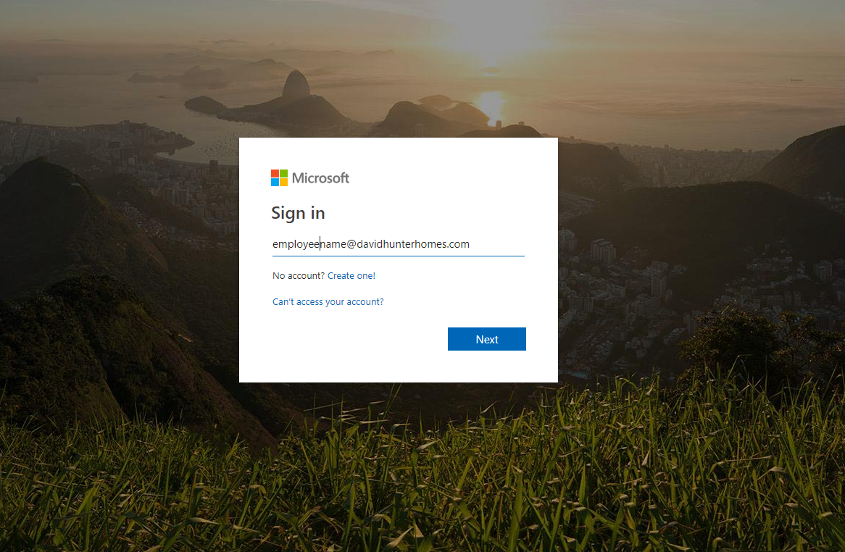

**IV) Disaster and Recovery Plan**

The company will partner with Rubrik Solution to manage database backups and recovery incase of a disaster that might occur. Backup and recovery software will be available through Microsoft VSS integration of the Windows operating system use throughout the company. All files with be store on backups in the interval of 5 hours. There will also be a archives of data that store clients information and records for the span of ten to twenty years store on backups. In doing so, the company will be able to provide its client with accurate yet non falsify information over the years.

